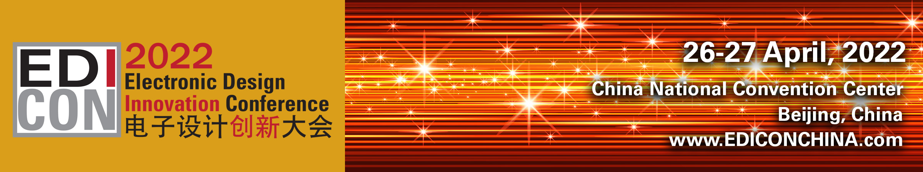

Exhibitor Profile

Please take the time now to complete your exhibitor information, which we will use in your online exhibitor profile listing and conference guide.
Please fill out your information (in English and Chinese) below and return to me for inclusion. Ms. Sonia Thai at sthai@horizonhouse.com.

Booth Number:__________ Company Name: ____________________________________________________
Address __________________________________________________________________________________
Telephone: ________________________________________________________________________________
Email:____________________________________________________________________________________
Website: __________________________________________________________________________________
Company Description: _______________________________________________________________________

Please advise which of the following product categories apply to your company:
- Amplifiers  - Antennas/Radomes  - Attenuators  - Connectors/Cables/Adapters  - Couplers/Dividers  - Diodes/FETS/Transistors  - Filters  - Hybrids  - Isolators/Circulators  - Linearisers  - Materials  - MEMS Devices  - Millimeter-wave Components  - MMICs  - Optoelectronic Components/Fiber Optics  - Oscillators  - Phase Shifters | - Power Supplies  - Printed Circuit Boards  - Publications  - Resistors/Capacitors/Inductors  - RFICs  - Saw Devices  - Services  - Shielding  - Signal Processing Components  - Software  - Synthesizers  - Systems and Subsystems  - Switches  - Terminations  - Test & Measurement Equipment  - Waveguide and Waveguide Components

